

217, Sheikh Rashid Building

P.O Box 56272, Dubai

United Arab Emirates

Tel: +971 4 2973236 / 04 2974007

Email: uae@verbat.com

PROJECT   
PROPOSAL

**POS Implementation for HAJT**

|  |  |
| --- | --- |
| **Prepared for:**  Hutchison Ajman International Terminal (HAJT)  Deepak Singh  IT Business Analyst  Ajman, U.A.E | **Submission Date:**  20 June 2017  **Proposal ID:** SW/20072017/1245/1 |

___________________________________________________________________________________________________________________________________________  
Conﬁdentiality Notice: This Proposal is conﬁdential and contains proprietary information and intellectual property of Verbanet Technologies LLC. Neither this proposal nor any of the information contained herein may be reproduced or disclosed under any circumstances without the express written permission of Verbanet.

© 2017 by Verbanet Technologies LLC. All rights reserved. Confidential.

___________________________________________________________________________________________________________________________________________

Project Contacts

|  |  |
| --- | --- |
| Client Information | |
| Project Name | POS Application |
| Client Name | Hutchison Ajman International Terminal (HAJT) |
| Client Address | Department of Port & Customs Ajman,  P.O.Box 388, Ajman, United Arab Emirates. |
| Phone Number | +971 6 7470 111 |
| Contact Person | Deepak Singh |
| Contact Person Email |  |
| Contact Person Phone Number | (+971) 6 747 0111. Extn. 260 |
| Contact Person Fax Number | +971 6 7470 333 |
| Verbat Information | |
| Contact Person | Ms. Joyce Daniel |
| Contact Person Phone Number | 04 2973236 |
| Contact Person E-Mail | Joyce.daniel@verbat.com |
| Address | PO Box 56272, Dubai |
| Physical Address | Flat 217, Sheik Rasheed Building, Hor Al Anz East, Dubai |
| Project Information | |
| Proposed Technology/Methodology | - |
| Anticipate Start Date | NA |
| Proposal Valid For | 30 Calendar days from the submission of the proposal |

**Table of Content**

1 Executive Summary 5

1.1 Solution Objective 6

1.2 Advantages of Proposed Solution 7

1.3 Why Verbat 7

1.4 Key Differentiators 8

1.5 Underlying Support Services 9

2 Functional Specification 10

3 POS System Architecture 10

4 Assumptions 11

5 Out of Scope 11

6 Technology Solution 12

6.1 Technical Configuration 12

6.1.1 Development Tools 12

6.1.2 Hardware Interface 12

7 Delivery Management 14

7.1 Project Management 14

7.2 Roles and Responsibilities 14

7.3 Phase Delivery Activity summary 15

7.4 Project Implementation plan 15

7.5 Deliverables 15

7.6 Release Planning 16

7.7 Risk and Contingency planning 16

8 Change Management 18

9 Project Effort & Timeline 19

9.1 Effort Estimate 19

10 Commercial overview 19

11 Miscellaneous 20

11.1 Warranty 20

11.2 Acceptance Criteria 20

11.3 General Terms and Conditions 20

11.4 Assumptions and Dependencies 21

11.5 Source Code & Intellectual Property Rights 21

12 Our Clients 23

# Executive Summary

Company Profile

Hutchison Ports Ajman (Here after referred to as the Client) is a member of Hutchison Ports. **Hutchison Ports** is the port and related services division of **CK Hutchison Holdings Limited (CK Hutchison)**. Hutchison Ports is the world’s leading port investor, developer and operator with a network of port operations in 48 ports spanning 25 countries throughout Asia, the Middle East, Africa, Europe, the Americas and Australasia. Over the years, Hutchison Ports has expanded into other logistics and transportation-related businesses, including cruise ship terminals, airport operations, distribution centers, rail services and ship repair facilities.

Client has requested Verbat to develop a Point of Sales System that can be integrated with e-Dirham. Client has an application called Orbits, which is their system of record for processing documents and document approvals. At present, end users of the system must go to a separate counter to make payments to process their documentation. When they receive proof of payment, they have to present the approval slip to the document approver to complete the business process.

Client would like to simplify this process by placing POS terminals with the document processor, so that the end users can make payments at the same counter. Once the payments have been made the transaction should be posted to Orbits.

Developing **Point of Sales Systems** using Microsoft .Net services is an area where Verbat has in-depth knowledge and expertise. Being the pioneers in Web based and windows based solutions across the major verticals, we are sure to help you enhance your customer engagement to drive differentiation. We bring proven methodologies and processes, global expertise in application development, and a legacy of best practices and ready-to-fit frameworks to expedite the development cycle and reduce the total cost of ownership.

Verbat is pleased to have received the request to submit the proposal and values it as a great opportunity to have a long term & mutually beneficial association with the client. Verbat has gone through the requirement and presents a technical proposal for the requested system. With the focus of delivering value to client, Verbat proposes a managed solution model for this requirement.

## Solution Objective

Verbat will develop a POS Solution that shall be capable of doing the following tasks

* Identify the transaction type i.e. e-Dirham, Master card, Visa etc.
* Initiate transactions from the terminal using the POS device
* Process transactions using the API provided by POS provider
* Continue processing transactions that had failed due to POS failures, so that it can be processed by another associate without having to start from afresh
* Identify the status/results of the transaction
* Post the results of the transactions to Orbits
* In case of failures, identify the reason for failures
* Assign terminals to POS machines so that work can continue in case of POS failures
* Software to manage the POS devices

Verbat will advise the client on the solution requirement, selection of technology, hardware & software requirement, server configuration & security. Verbat shall be in charge of the complete turnkey operations of the training management system. The scope of the system includes

* Study, Design, Development & implementation of the CMS Web site
* QA & UAT
* Application documentation (Wireframes, Requirements, Specifications & Test Cases)

.

Verbat’s Solution architects have conducted a thorough research on the requirements and have come to the conclusion that our proposed solution, which is detailed further in this document, will meet the requirements put forth by the client. And the proposed solution will be delivered in a phased approach as per Verbat‘s managed solution model.

**Strong and Scalable platform:** The platform proposed will be strong and scalable enough to accommodate future enhancements.

**Accelerated solution:** The framework would act as a solution accelerator. It would provide the basic building blocks which could be reused in future for building new components and features as part of enhancements

**High performance:** The light weight framework used consumes fewer system resources thereby making the application perform faster

* System shall be available 24/7
* System shall be performant without any lags or delays

**Security:** The application will be developed considering various aspects of security.

* Database Server shall be housed in a secure location, either on the company’s premises or on the cloud
* System shall work on the companies LAN/WAN without the need for an internet connection (Intranet application)
* Only authorized personnel shall have access to the system
* Encryption shall be used to secure sensitive information
* Security against SQL injection attacks and cross browser scripting attacks

## Advantages of Proposed Solution

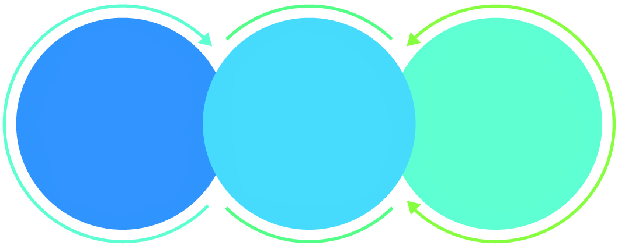

01

Agile development offering reliable, scalable and secure solution

02

Smooth transition and quicker completion of processes

03

User friendly interfaces enabling easy navigation between screens

## Why Verbat

Globally Accredited

Software Consultation Partner

Spearheaded by a   
team of Technology and   
Management Leaders



Over 16+ years of customer experience with Global   
Corporations

Service in Banking, Retail, Logistics, Construction & Contracting, Fashion, Manufacturing, Hospitality, Automotive, Healthcare and Government sectors

IT Strategy, Application Development and Maintenance, Testing Services, Information Management and Digital Marketing efforts



## Key Differentiators

Delivered digital transformation expertise to global customers for over a decade by following industry best practices to maximize ROI for client

Keen technology intelligence combined with aggressive market research to deliver solutions that achieve results with measurable value

Enable access to global consulting expertise with strong local market and business knowledge

Commercial Model that is customizable for your business needs

Reuse of code libraries for Rapid Application Development

1,000,000 plus man-hours of expertise in technology frameworks spanning Microsoft, Open Source, mobility platforms and other proprietary IT technology

Partners top technology vendors to bring in the latest and best services in integration, collaboration, and development

Commercial Model that is customizable for your business needs

Proven Methodologies & Processes

Investment in R & D

Strong Local Presence

Flexible commercial Models

Technology Associations

Code Repository

Software Development Experience

Offshore Development Centre

## Underlying Support Services

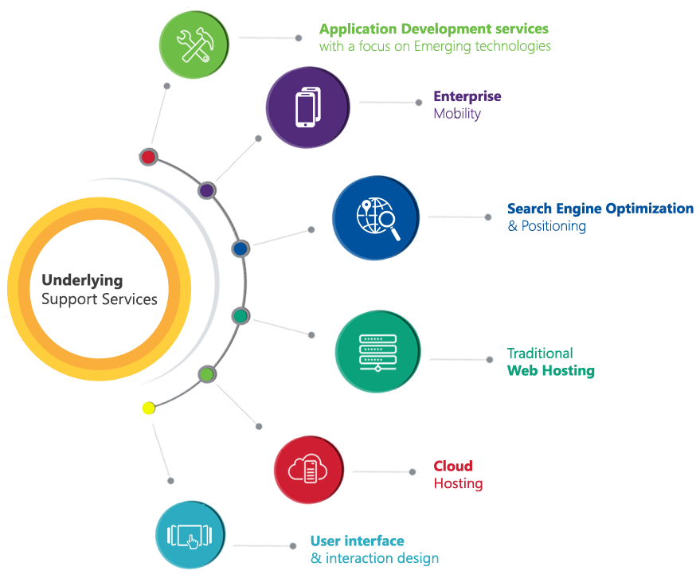

# Functional Specification

To develop the CMS based web application, Verbat proposes that the application be **developed in a single phase**. Functional specs for the application is detailed below.

|  |
| --- |
| Bilingual UI |
| POS Device Integration |
| Payment Module Service Integration to e-Dirham |
| Payment Mode - Pay |
| Payment Mode - Pre-Auth. and Capture |
| Payment Mode - Refund |
| Payment Mode - Reversal |
| Payment Response Management |
| Payment accepting screens and functionality |
| Integration with client application |
| Rerouting request for device failure to a new counter |
| **Web Service layer (Middleware)** |
| POS device interface layer |
| Internal application interface layer |
| Message translation service |
| Payment Mode - Pay |
| Payment Mode - Pre-Auth. and Capture |
| Payment Mode - Refund |
| Payment Mode - Reversal |
| Payment Response Management |
| Reporting (Avg. 6 hrs. / report) X 5 |

# POS System Architecture

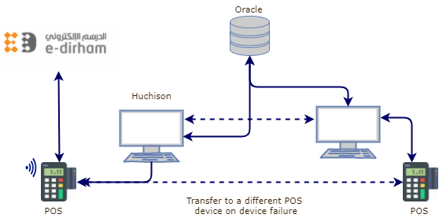

**Middleware**

# Assumptions

The project solution and technology is created from the initial understanding of the requirement shared with Verbat through mails and meetings. The proposed solution is based on the following assumptions;

* Color theme shall be provided by the client
* Client shall provide licensed images and logos in specified size & format
* Client shall buy the themes, skins or templates needed for customizing the look and feel
* Client shall provide logos, images & branding guidelines
* Client shall provide the text and associated images for languages other than English
* Device/s and required SDK and Test cards will be provided by the client
* Merchant ID and other required payment gateway details will be provided by the client
* Required source code of the modules should be provided if it require integration with any existing application
* Access to the database will be provided to update the payment transactions

# Out of Scope

With the ever evolving digital market, the requirement needs should be clear to both the parties involved, hence the importance of mentioning the out of scope details of the project. Following are considered to be out of scope while creating this proposal.

* Purchase of images, fonts
* Adding new features to the application other than mentioned in this proposal
* Any language other than English
* Manual data entry
* Database migration
* Content writing
* Annual Maintenance Contract ( Bug fixing, debugging, enhancements, develop new modules)
* Physical deployment at client’s site
* Data Replication
* Software packaging and deployment

# Technology Solution

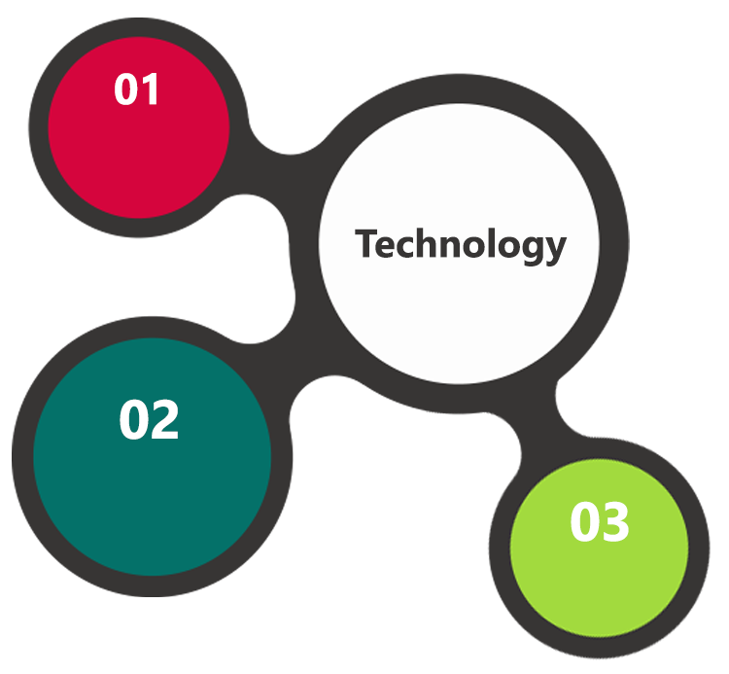

C#, MVVM

Oracle 11g  
Windows 2012 OS

SSL

HTML 5  
JavaScript  
CSS3

A major portion of the application will be developed using Microsoft technology employing a mix of web services and web interfaces to configure the application.

## Technical Configuration

### Development Tools

* Visual Studio
* MS SQL Server Management Studio & Photoshop
* .NET SDK

### Hardware Interface

The application is reliant on hardware interfaces to provide a seamless automated user experience.

* Computer with Windows 8 or 10 OS
* Oracle DB Server

# Delivery Management

## Project Management

The Verbat development center strictly follows industry standards on quality. The project management is process governed by the Verbat Quality Management system and is put to verification through internal audit programs that happen from time to time.

Verbat will dedicate a project manager for the proposed implementation. Verbat proposes Client to identify one project manager who will be driving activities to be undertaken by Client to be the single point of contact for Verbat.

## Roles and Responsibilities

Verbat will assign a dedicated Project Manager/Project Lead to lead the project, who will be the first point contact for Client. He/she will be responsible for planning and managing the various activities within the project. He/she will work closely with Client Project Manager, to give periodic status updates and ensure high level of visibility and comfort on the progress of the project.

The Project Manager/Project Lead will lead the co-ordination between Verbat and Client, thus enabling smooth transitioning of Client requirements to the Verbat’s offshore delivery team, and provide visibility as well as comfort on the progress of the services to Client.

He/she will have periodic meetings with Verbat’s Senior Management, thus ensuring Verbat’s Management commitment and focus on Client initiatives.

*Note: detailed qualification and experience of the persons involved in the project will be shared be finalizing the project on request*

## Phase Delivery Activity summary

|  |  |
| --- | --- |
| Activities | Description |
| Detailed requirement Analysis | Verbat team to conduct detailed study of requirement for the phase. If clarification is required, team will reach out to Client for more information and/or time for discussions. |
| Software Requirement Specification document (SRS) | Once the requirement analysis is completed, Verbat team will submit the SRS document for approval |
| UI/UX Design, Prototyping | Based on the SRS, Verbat UX/UI team will work on the UI/UX of the screens and submit a prototype for approval |
| Functional Specification Document (FS) | Once the Prototype. UI/UX is approved, Verbat shall submit an FS document for approval. |
| Development | Actual system development starts based on the FS. This involves detailed design and software development of Web Admin, API & iOS and Android mobile app. |
| Testing | Test Planning, test plan creations, internal, integration testing and user acceptance testing. |
| Deployment | Deploying the latest built in the Verbat Test Server. |

## Project Implementation plan

Verbat will be providing the solution in a phased approach which ensures minimum viable solution for quick wins with core focus on the long term business objective and outcome. Once the implementation of phase 1 is over, Verbat will initiate the application maintenance process which continues to extend after the implementation of successive phases.

## Deliverables

* Software Requirement Specification Document (SRS)
* Wire Frames for Key Screens
* Functional Specification Document (FS)
* Fully Developed & Tested Application
* Test Cases
* Fully commented source code
* User Manual (English)
* Install shield executable

## Release Planning

* Client will be informed about the release date and time through email.
* Client performs the UAT

## Risk and Contingency planning

Verbat has identified various risk factors associated with this assignment and understands the impact of these risk factors on the project schedules. The objective of this section is to highlight for both Verbat and client, the risk factors, to analyze the impact of the risks on project execution, and to propose strategies to control and reduce the impact of the risk factors.

These various risks, which could arise during the project, are tabulated below along with mitigation implementation.

| Type of risk | Impact | Risk Mitigation | Risk Handling |
| --- | --- | --- | --- |
| Scope Creep | H | Functions and features will be detailed in system requirement documents and will go through client approval. Once this document is approved, any change to requirement will go through change management review for possible impact assessment. | Proper change management procedure will be implemented. |
| Delay in customer feedback | H | The plan is prepared with enough lead-time for customer reviews and approvals.  The customer is indicated with the dates when the document is expected after review and approval. | The request for feedback will be escalated if not attended at the right time so that the schedules are not affected. Deemed acceptance criterion is set up front and will be followed. |
| Non-availability of necessary software’s, frameworks, database instances and infrastructure at client’s hosting environment(If hosting support is provided by Verbat) | M | Client will be informed in advance on these requirements. | Possible impact to schedule. |
| Manpower attrition | L | All efforts would be made to ensure process dependence rather than being person dependent. As a risk mitigation plan Verbat will train backups. | A new person will be identified as early as possible, provided the required project-specific training and mentored by the senior members of the team to minimise impact of attrition on the project. |

*H-High, M-Medium, L-Low, NA-Not Applicable*

# Change Management

Any addition which comes out of the project scope, upon and after the launch of the tool will be considered as change management. Verbat recommends the following change management procedure for the same.

* Any change which comes out of the project scope, which was discussed, documented, and mutually approved by both the parties in the requirement stage, will be carried out only through raising a change request.
* Change request will be studied and an impact analysis on the existing work flow will be performed.
* On finalizing the impact, effort estimation for the change will be calculated and raised as additional requirement.
* Verbat will initiate the change request only after getting a formal approval from the client for the additional changes raised.
* Any change from the scope will be charged at **AED 1200 per man day effort** and approval from the clients will be availed before commencing on any change management.

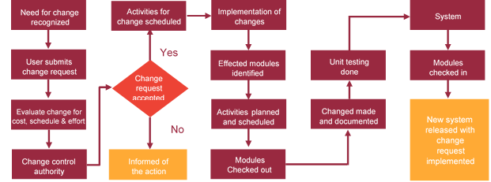

# Project Effort & Timeline

## Effort Estimate

The effort estimated for delivering the application as specified in this document will be as below:

|  |  |  |
| --- | --- | --- |
| **Description** | **Man Days** | |
| Total Delivery Days | | 54 |
| Total Effort | | 44 |
|  | |  |

# Commercial overview

|  |  |  |
| --- | --- | --- |
| **Description** | | **Cost (USD)** |
| Development of the POS based application | USD XXX,XX.00 | |
| **Total** | | **$ X,XXXX.XX** |

# Miscellaneous

## Warranty

Verbat shall provide a bug ﬁx warranty at no additional cost for 30 days from the date of acceptance of the project, for correction of any errors in the developed application that may be attributed to Verbat.

However, this does not cover modifications by Client, or use of the application on an environment other than the proposed environment, or other circumstances outside Verbat’s reasonable control. In such a case Verbat reserves the right to charge for its services.

All error corrections will be executed at Verbat India office. In the event of any need for on-site work, all expenses incurred for such trips will be payable to Verbat by Client.

## Acceptance Criteria

* UAT sign off should happen within 14 Days from the release of each module/ Phase and the acceptance confirmation needs to be mailed to Verbat failing which Verbat will consider the project as approved by the client.
* Any comments or reason for rejection need to be documented and the same needs to be sent as an email from the official mail id of client to Verbat.

## General Terms and Conditions

* Offer Valid for 30 calendar days from the date of submission of the Proposal
* An average of 20 working days are assumed in a month
* This proposal and all technical/ functional specifications have been derived or concluded from the data shared via email / information's transferred during the initial requirement analysis meetings and conversations. Verbat reserves the right to amend the terms of this proposal, should the SOW terms, functional features and functionalities change during the course of the project
* The applications will be built as per the specifications agreed mutually. Any changes will be executed through a deﬁned change management process between both parties
* All Source Code and other project artefacts would adhere to the Verbat document templates and internal coding standards
* Acceptance criteria shall be based on the clauses which were mutually discussed between Verbat and client at the Requirement Analysis phase and the same will be documented and approved by both parties through official emails
* Final deployment to production server pursuant to completion of all payments

## Assumptions and Dependencies

* During the requirement gathering phase, authorized personnel from the Client’s side is expected to be available for discussion and finalizing the HLD (High Level Design), before development commences.
* Type of reports and formats, if under the scope of the project, needs to be specified by Client before project sign off.
* Workflows need to be specified/ confirmed by client before project signoff.
* All queries regarding the client requirement and any queries which may hinder the project advancement at any stage should be answered by the client within 24 hours from the time of initiation, failing which the time delay will get added to the actual effort which was estimated.
* Verbat assumes that all sign-offs from Client will be provided within agreed and specified timeframe.
* Client will provide all the necessary contents, both text and image, before starting the project in the format suggested by Verbat (if any).
* The client should provide the relevant information and data well in time for the execution of a related activity. Non- availability of this information or data may lead to an interruption of work which may result in a delay in delivery as well as additional costs to the client.

## Source Code & Intellectual Property Rights

* Upon completion of the Project and 100% completion of the payment, client will have access to the source code except for propriety codes, developer tools and third party application / modules like Microsoft Dynamics Products, Share Point LMS etc.
* The solution offered will be the intellectual property of the client and will be made available to the client on an “unlimited license” basis.
* Modifications by third party/person: No person or organization, other than Verbat or any person authorized by Verbat in writing, has any permission to modify/change the software Solution to be eligible to get continued support from Verbat as per the support terms defined under this document.
* Liabilities/Damages: Verbat accepts no liability or damages of any kind arising out of use or non-use of the software delivered. The responsibility of testing of software lies with Client.

# Our Clients

**UAE University**

Education

Transportation

**Canada Cartage**

Construction

Services

Finance

We look forward to hearing from you soon and hope that you will give us the privilege to work with you in meeting your business goals. Thank you.

Thank You



©   
1999 - 2017. All Rights Reserved   
Verbanet Technologies LLC  
www.verbat.com